





6. After completing the programming assignment, adjust the l2 regularization on the notMIST logistic regression model. Try values 1, 0.1, 0.01, and 0. Which produces the lowest error? Why do you think this is the case?

Values at 1.

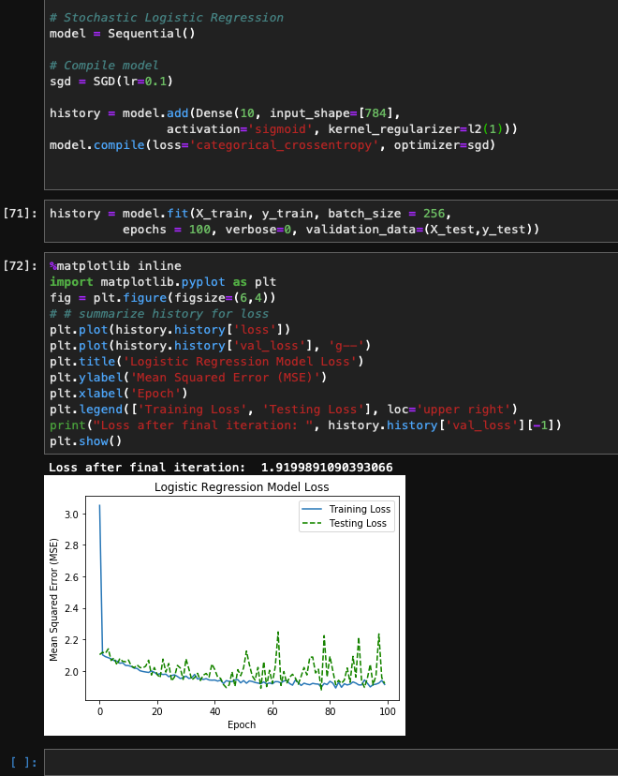

Values at 0.1

Values at .01

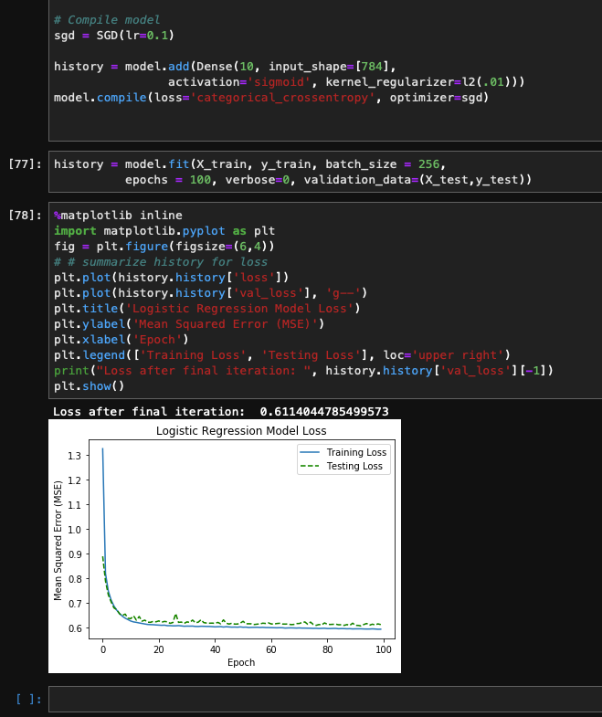

Values at Zero

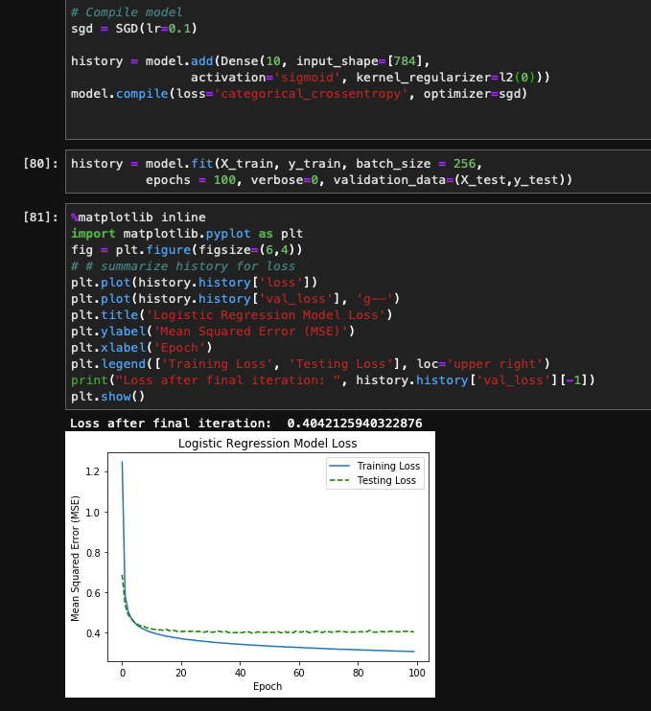

The L2 Regularization is referring to the Ridge Regression in which add the squared magnitude of coefficient as a penalty term to the loss function. In essence this adjustment is to make sure the model does not become overly complex and over fits the data. As seen in the images above an L2 Regularization of 0.01 seems to have the most stable model. However, after we chose 1 or zero the extra added magnitude pushes the model to the extremes.

https://towardsdatascience.com/l1-and-l2-regularization-methods-ce25e7fc831cs